1 Manual for how to run application

* 1. Download the application

Github link: <https://github.com/codeskyworld/MathGame>

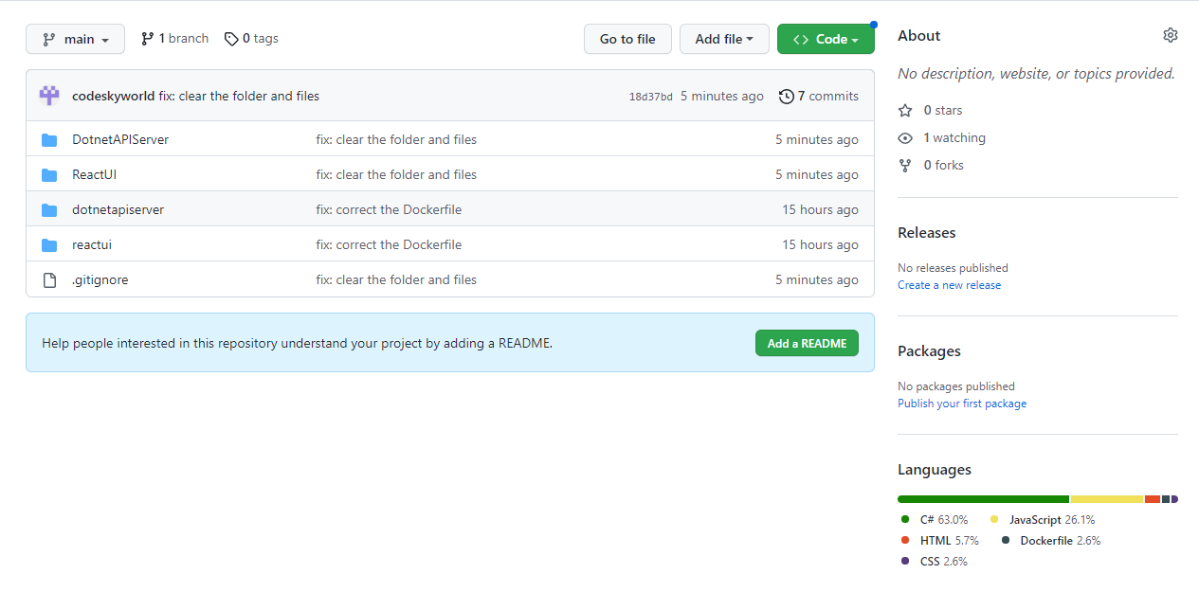

* 1. Run application for back end

In the folder of “\*\MathGame\DotnetAPIServer”, double click “WebServer.sln” to open the application in the visual studio, and run the API.

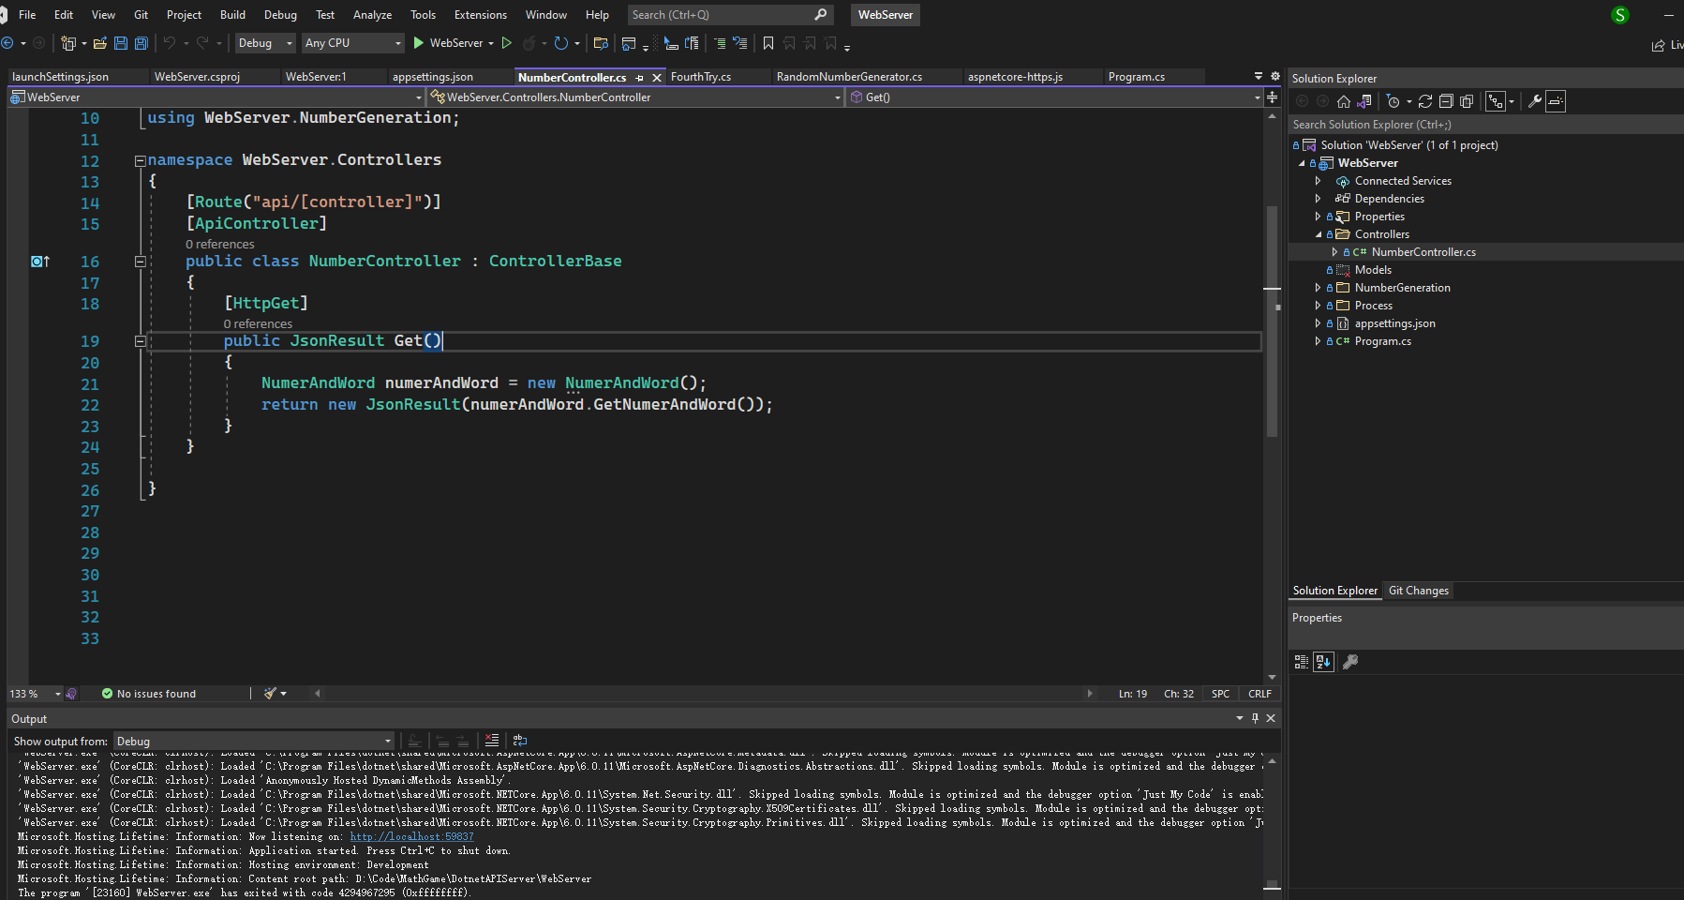

* 1. Run application for the front end

Use visual studio code to open the folder of \*\MathGame\ReactUI, open a new terminal as below, run “npm install” in the console of VS code, which can install all the dependencies for React. Then, run “npm start”, which can run React application.

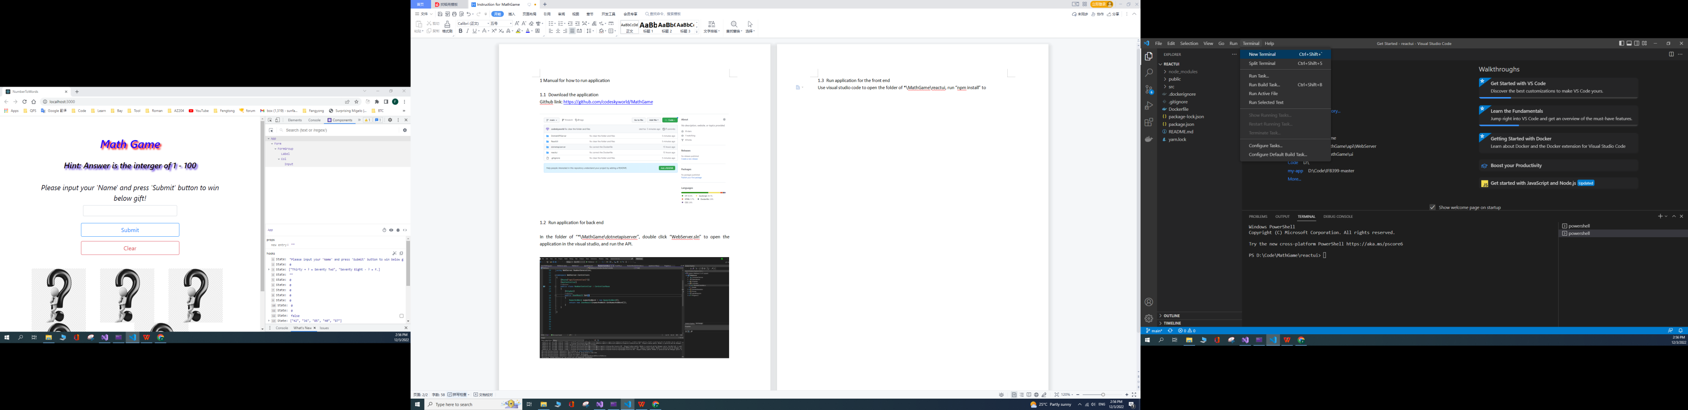

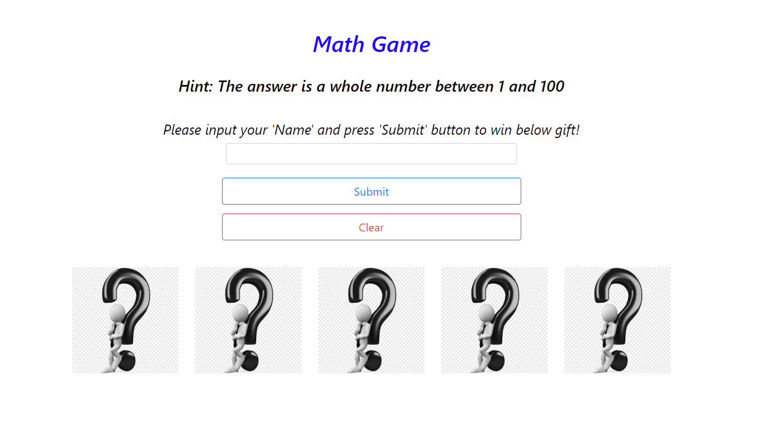

2 How to play MathGame

Please input your name first. Then input the answer for the math questions. If you answer correctly, “question mark” image will display the “gift” image. You will also get the grade.

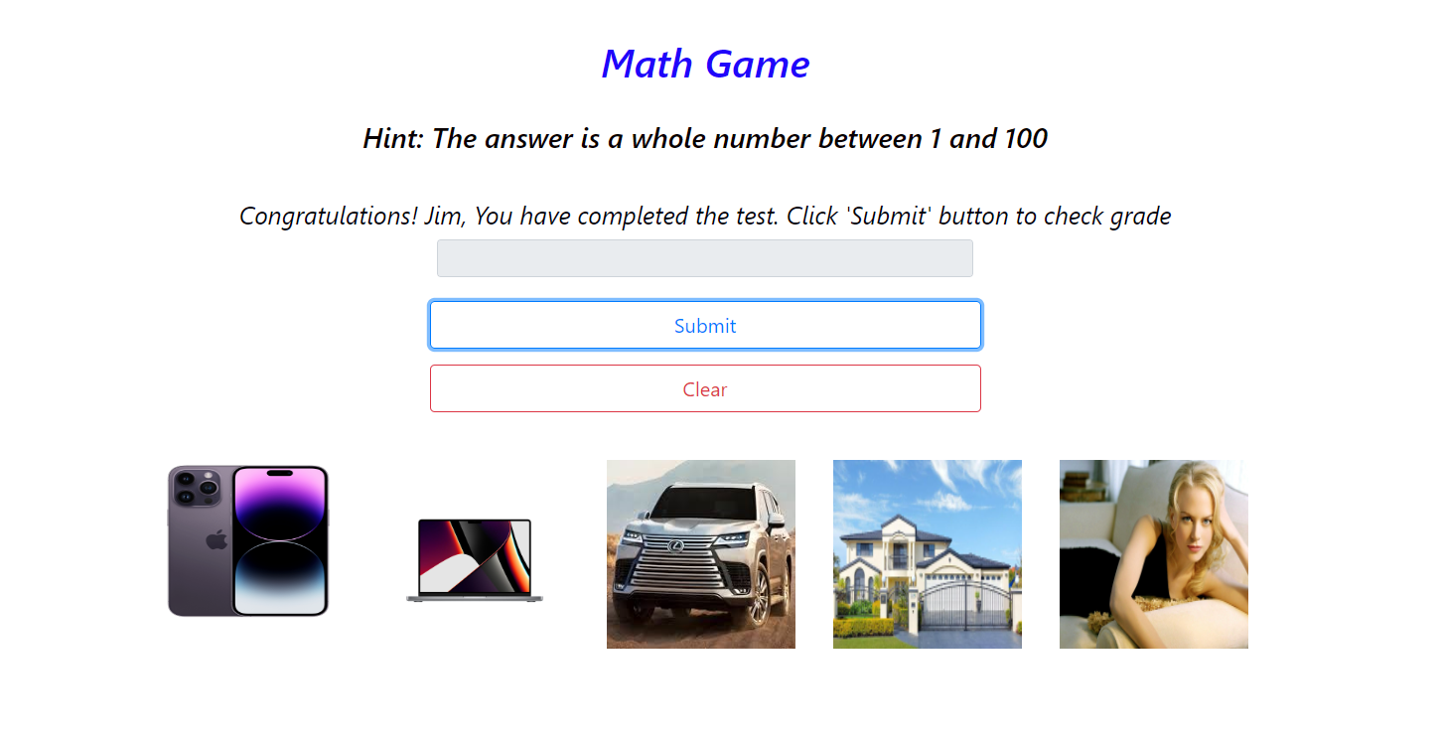3 Skill set for MathGame

3.1 Coding for front end

Html, CSS, Javascript, React, Bootstrap

3.2 Coding for back end

C# and .Net 6

3.3 Development Tool

Front end: Visual studio code, Chrome

Back end: Visual studio

Source control: Git, Git-extension

4 Something could be further improved

4.1 Add CI/CD pipleline using Gitlab

4.2 Create docker images for front end and back end application. Actually, I have completed the “Dockerfile” which can be found in source code, and created docker images in the local Ubuntu subsystem.

4.3 Deploy the images in the Linux virtual machine on the Cloud of Azure or AWS using docker hub and docker, then this web application can be browsed online.

4.4 Can also add the countdown in the web page for “Math Game”.

4.5 Add unit test